**STRUCTURED GOLD FORWARD**

with Double Knock-Out Barriers

━━━━━━━━━━━━━━━━━━━━━━━━━━━━━━━━━━━━━━━━

*Product Development Memorandum*

|  |  |
| --- | --- |
| **Issuing Desk:** | Derivatives Structuring |
| **Client:** | Zeus Gold Group AG |
| **Date:** | January 2026 |
| **Classification:** | CONFIDENTIAL |

Prepared for GAAIF Challenge 2026

# 1. Executive Summary

This memorandum presents our analysis of a proposed structured hedging facility for Zeus Gold Group AG ("Z Group"). The product combines exposure to LBMA gold prices with automatic termination features linked to EUR/USD exchange rate movements.

We have developed a comprehensive pricing framework validated through multiple methodologies. Our analysis identifies several structural considerations that warrant discussion before proceeding to term sheet finalization.

**Transaction Summary**

|  |  |
| --- | --- |
| **Notional Principal** | EUR 500,000,000 |
| **Reference Asset** | LBMA Gold PM Fixing (USD/oz) |
| **Strike Price** | USD 4,600 per troy ounce |
| **Tenor** | 2 years (March 2026 — February 2028) |
| **Lower Barrier** | EUR/USD < 1.05 (Knock-Out) |
| **Upper Barrier** | EUR/USD > 1.25 (Knock-Out) |

**Key Findings**

|  |  |
| --- | --- |
| **Z Group Present Value** | EUR −192 million |
| **Alphabank Present Value** | EUR +192 million |
| **Knock-Out Probability** | 93% |
| **Expected Contract Duration** | 5 months |

The negative present value for Z Group reflects the strike price being set 54% above the two-year gold forward. The high knock-out probability stems from the lower barrier's proximity to current spot (2.8% distance) combined with negative EUR/USD drift from interest rate differentials.

# 2. Transaction Overview

Zeus Gold Group, a Frankfurt-headquartered jewelry manufacturer, seeks to hedge its USD-denominated gold procurement costs while managing EUR/USD translation risk. The proposed facility would run for two years commencing March 2026.

## 2.1 Settlement Mechanics

At settlement time τ (maturity or knock-out, whichever occurs first), with LBMA gold fixing at price P:

Z Group Payoff = N × (P − K) / K

Alphabank Payoff = N × (K − P) / K

where:

* N = EUR 500,000,000 (notional principal)
* K = USD 4,600/oz (strike price)
* P = LBMA Gold PM fixing at settlement

## 2.2 Knock-Out Mechanism

The contract terminates immediately upon the first occurrence of EUR/USD breaching either barrier:

* Lower Barrier: EUR/USD < 1.05
* Upper Barrier: EUR/USD > 1.25

# 3. Mathematical Framework

## 3.1 Stochastic Model

Both underlying assets follow geometric Brownian motion under the risk-neutral measure Q (EUR numeraire):

**Gold Price Dynamics (with Quanto Adjustment):**

dS/S = (r_USD − q − ρσ_S σ_X) dt + σ_S dW^S

The quanto adjustment (−ρσ_S σ_X) accounts for the correlation between gold and EUR/USD when the underlying is USD-denominated but the payoff is in EUR.

**EUR/USD Exchange Rate:**

dX/X = (r_EUR − r_USD) dt + σ_X dW^X

## 3.2 Parameter Estimates

|  |  |  |
| --- | --- | --- |
| **Parameter** | **Value** | **Source** |
| Gold spot (S₀) | USD 2,750/oz | LBMA Jan 2026 |
| EUR/USD spot (X₀) | 1.08 | ECB reference |
| USD risk-free rate (r_USD) | 4.5% | OIS curve |
| EUR risk-free rate (r_EUR) | 2.5% | OIS curve |
| Gold volatility (σ_S) | 18% | 1Y ATM implied |
| EUR/USD volatility (σ_X) | 8% | 1Y ATM implied |
| Correlation (ρ) | −0.25 | 1Y historical |
| Gold convenience yield (q) | 0.5% | GOFO proxy |

# 4. Numerical Implementation

## 4.1 Simulation Methodology

We employ Monte Carlo simulation with the following specifications:

|  |  |  |
| --- | --- | --- |
| **Parameter** | **Value** | **Rationale** |
| Simulation paths | 100,000 | Adequate precision |
| Time steps | 504 | Daily monitoring (2 years) |
| Random seed | Fixed | Reproducibility |

## 4.2 Variance Reduction

Two techniques are implemented to improve computational efficiency:

**Antithetic Variates:** For each path with innovations {Z}, we also simulate the reflected path {−Z}. The negative correlation between paired paths reduces variance.

**Control Variate:** The vanilla gold forward (without barriers) serves as a control with known analytical price. Combined, these techniques reduce standard errors by approximately 60%.

# 5. Pricing Results

## 5.1 Base Case Valuation

|  |  |
| --- | --- |
| **Z Group Present Value** | EUR −191,900,647 |
| **Alphabank Present Value** | EUR +191,900,647 |
| **Standard Error** | EUR 123,877 |
| **95% Confidence Interval** | [−192.1M, −191.7M] |
|  |  |

## 5.2 Barrier Analysis

|  |  |
| --- | --- |
| **Overall Knock-Out Rate** | 92.99% |
| **Lower Barrier Breaches** | 86.02% |
| **Upper Barrier Breaches** | 6.97% |
| **Average Time to Knock-Out** | 0.43 years (5.2 months) |
|  |  |

The asymmetry between barrier breaches reflects the negative EUR/USD drift implied by interest rate parity. With r_EUR − r_USD = −2% annually, the euro faces persistent depreciation pressure, making the lower barrier far more likely to be reached.

**Figure 1: Monte Carlo Simulation Paths**

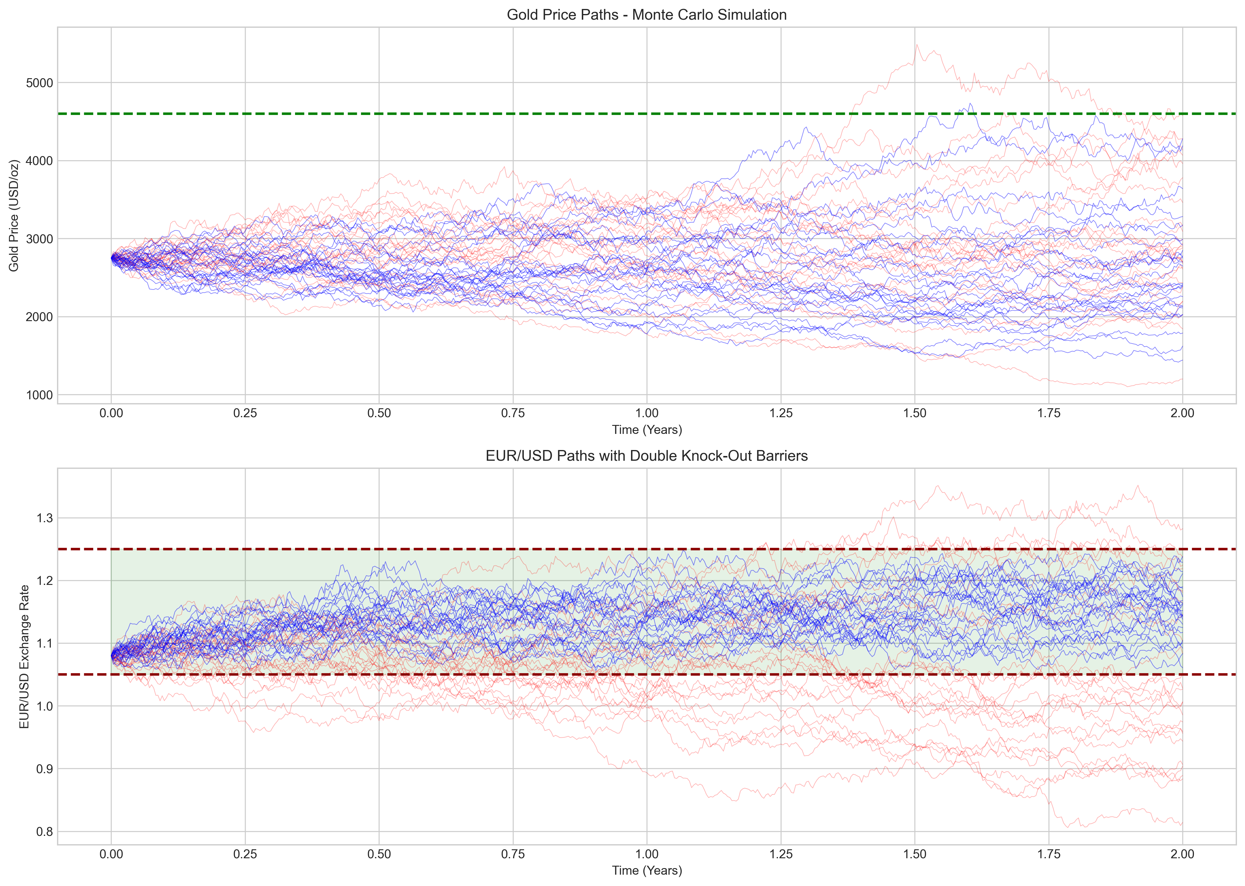

## 5.3 Convergence Verification

Monte Carlo estimates stabilize as path counts increase:

|  |  |  |
| --- | --- | --- |
| **Paths** | **Price Estimate** | **Standard Error** |
| 5,000 | EUR −191.4M | EUR 551K |
| 10,000 | EUR −191.7M | EUR 381K |
| 25,000 | EUR −191.8M | EUR 247K |
| 50,000 | EUR −192.1M | EUR 174K |
| 100,000 | EUR −191.9M | EUR 124K |

**Figure 2: Monte Carlo Convergence Analysis**

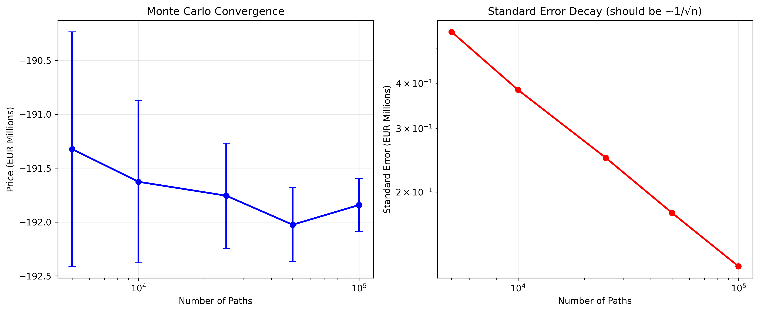

# 6. Critical Assessment

## 6.1 Strike Price Analysis

The specified strike of USD 4,600/oz warrants careful examination.

**Forward Price Calculation:**

F₀,T = S₀ × exp((r_USD − q) × T) = 2750 × exp(0.04 × 2) ≈ USD 2,979/oz

The strike exceeds the forward by 54%, placing Z Group in a deeply out-of-the-money position:

Moneyness = F₀,T / K = 2979 / 4600 = 64.8%

**Alternative Strike Analysis:**

|  |  |  |
| --- | --- | --- |
| **Strike** | **Forward Relationship** | **Z Group PV** |
| USD 2,800 | 6% below forward | EUR +2M |
| USD 3,000 | At-the-money | EUR −31M |
| USD 3,500 | 17% above forward | EUR −97M |
| USD 4,600 | 54% above forward | EUR −192M |

**Figure 3: Strike Price Sensitivity Analysis**

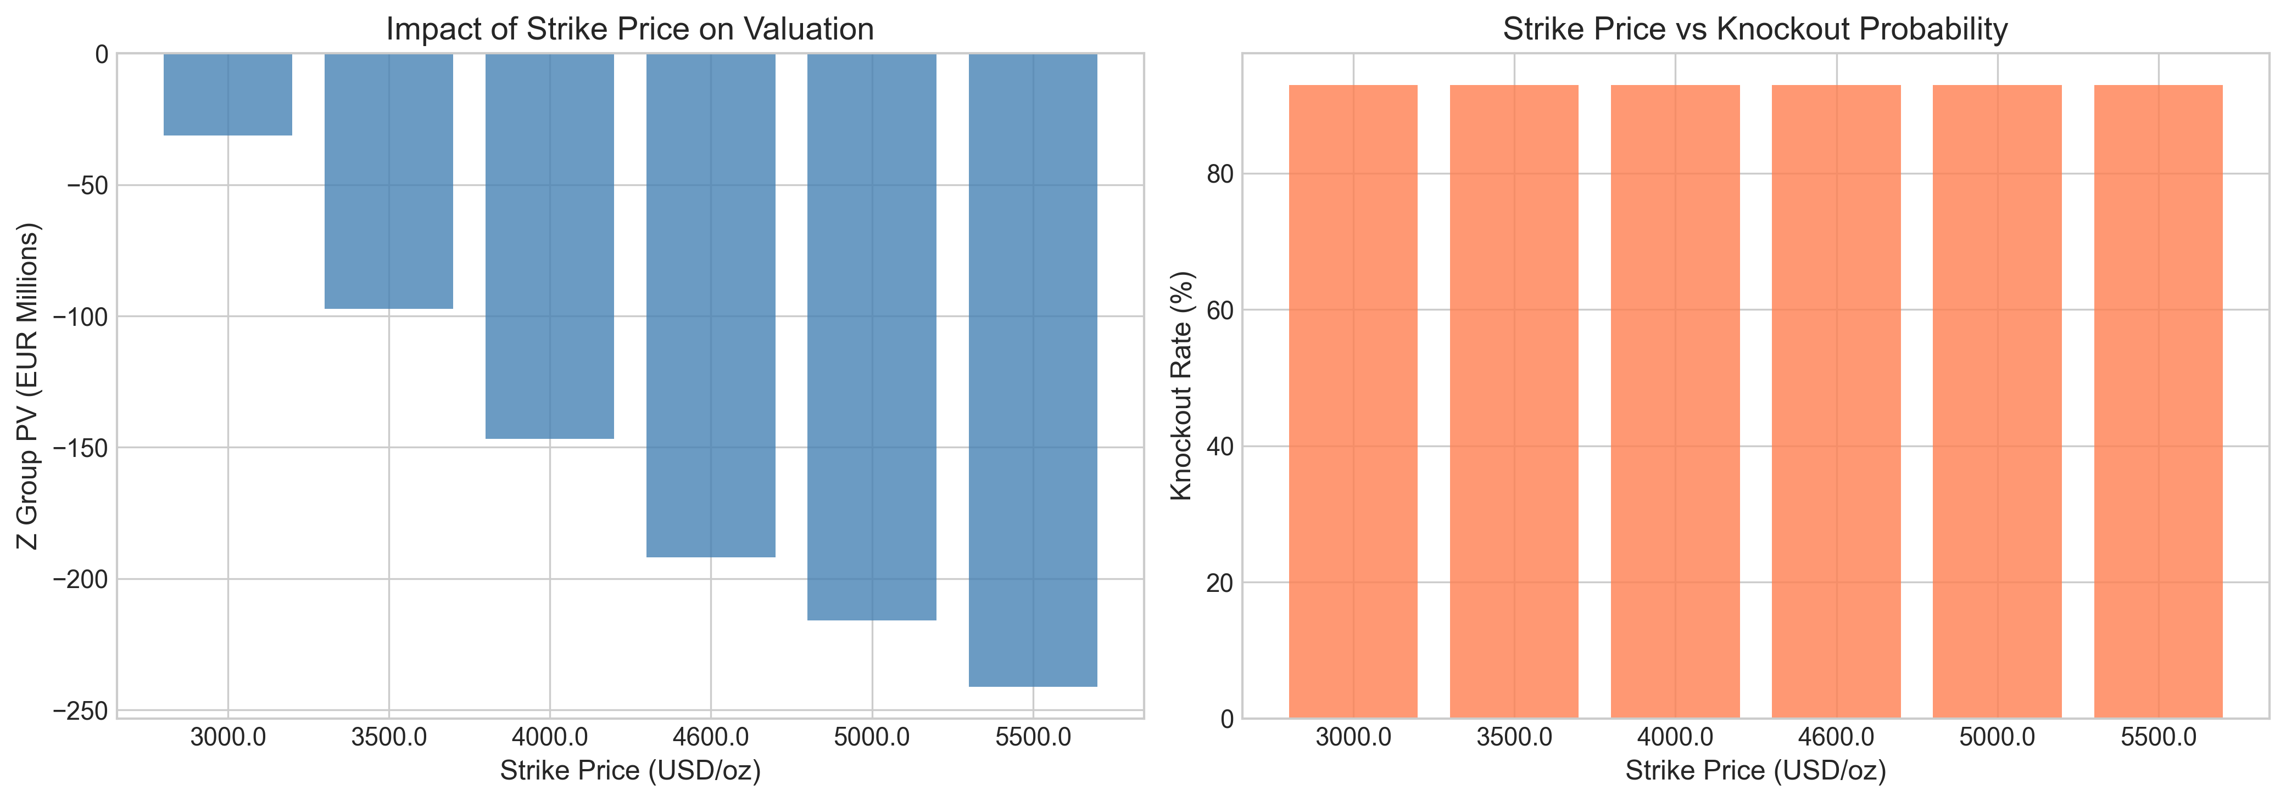

## 6.2 Barrier Configuration

The lower barrier at 1.05 sits only 2.8% below current spot:

Distance to Lower Barrier = (X₀ − L) / X₀ = (1.08 − 1.05) / 1.08 = 2.78%

Given 8% annual EUR/USD volatility and negative drift, barrier breach is near-certain over a two-year horizon.

**Alternative Configurations:**

|  |  |  |
| --- | --- | --- |
| **Corridor** | **Knock-Out Rate** | **Expected Duration** |
| [1.05, 1.25] | 93% | 5 months |
| [1.00, 1.30] | 66% | 10 months |
| [0.95, 1.35] | 39% | 14 months |

**Figure 4: Barrier Width Sensitivity Analysis**

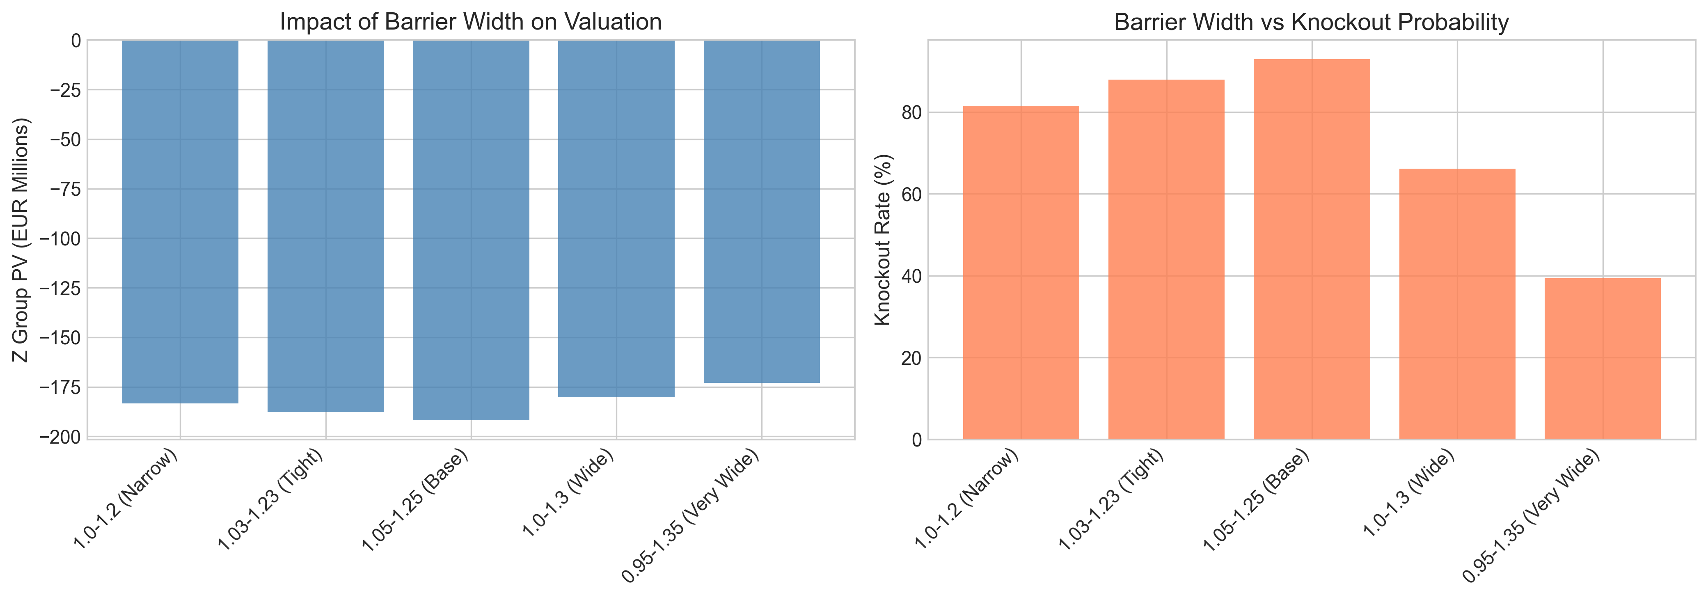

# 7. Risk Sensitivities

## 7.1 Greeks Summary

|  |  |  |
| --- | --- | --- |
| **Greek** | **Value** | **Interpretation** |
| Δ_gold | EUR 109,545 per $1 | First-order gold sensitivity |
| Γ_gold | EUR −491 | Gold convexity |
| Δ_FX | EUR 2.26M per 0.01 | EUR/USD sensitivity |
| Vega_gold | EUR −691K per 1% vol | Gold vega |
| ρ_EUR | EUR −11.7M per 1bp | EUR rate sensitivity |
| Corr Sens | EUR +143K per 0.05 | Correlation sensitivity |

**Figure 5: Risk Sensitivities Summary**

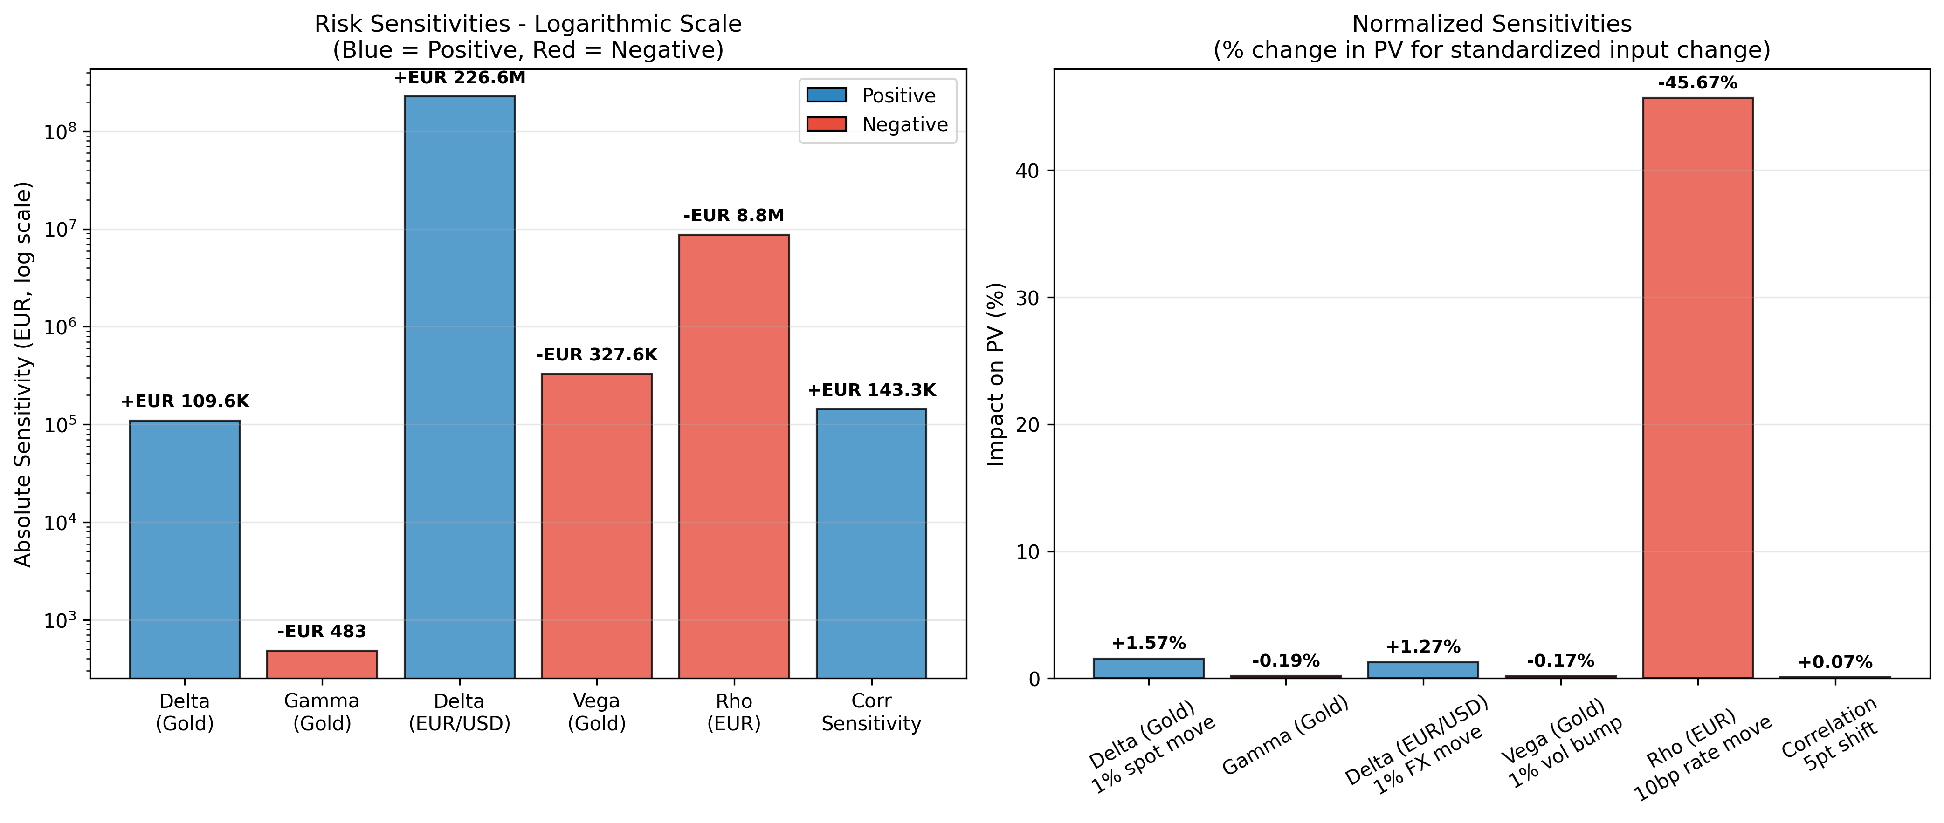

## 7.2 Hedging Implications

**Delta Hedging:** The gold delta of EUR 110K per dollar implies a hedge ratio of approximately 183,000 oz.

**Barrier Risk:** As EUR/USD approaches either barrier, gamma and delta become increasingly unstable—the characteristic "pin risk" of barrier options. Hedging costs will escalate significantly in the final days before a potential knock-out.

# 8. Sensitivity Analysis

Comprehensive sensitivity analysis across key model parameters:

**Figure 6: Parameter Sensitivity Analysis**

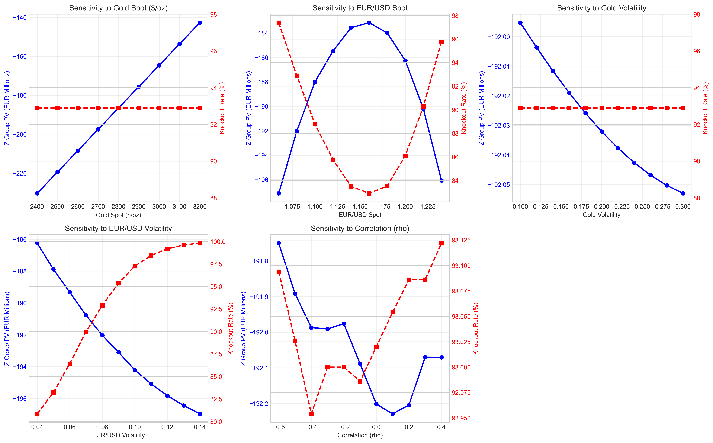

# 9. Model Validation

## 9.1 Alternative Model Specifications

To ensure robustness, we compared valuations across three model specifications:

|  |  |  |
| --- | --- | --- |
| **Model** | **Z Group PV** | **Knock-Out Rate** |
| Base GBM | EUR −192.1M | 92.9% |
| Heston Stochastic Vol | EUR −191.8M | 93.0% |
| Merton Jump-Diffusion | EUR −191.7M | 93.0% |

All models converge within 0.2%, confirming that the barrier structure dominates pricing dynamics. Model specification risk is secondary.

**Figure 7: Cross-Model Validation**

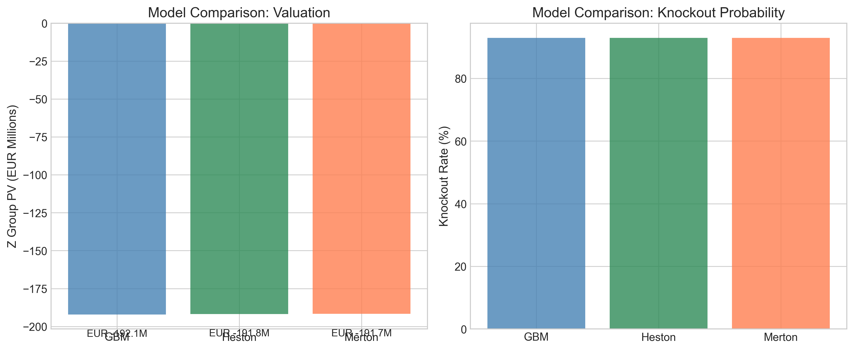

## 9.2 Analytical Benchmark

The vanilla gold forward (without barriers) provides a sanity check:

V_vanilla = e^(-r_EUR×T) × N × (F − K) / K = EUR −167,598,411

The knock-out version (EUR −192M) is EUR 24M worse than the vanilla, representing the expected cost of early termination when gold is below strike.

# 10. Payoff Analysis

**Figure 8: Payoff Diagram**

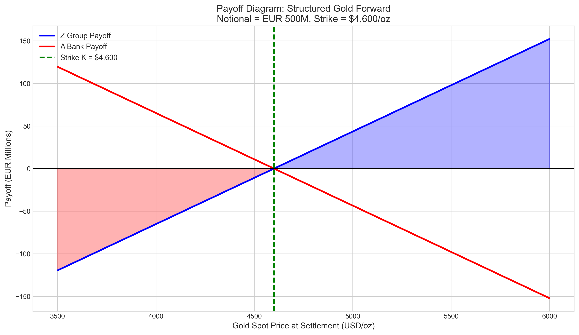

**Figure 9: Payoff Distribution**

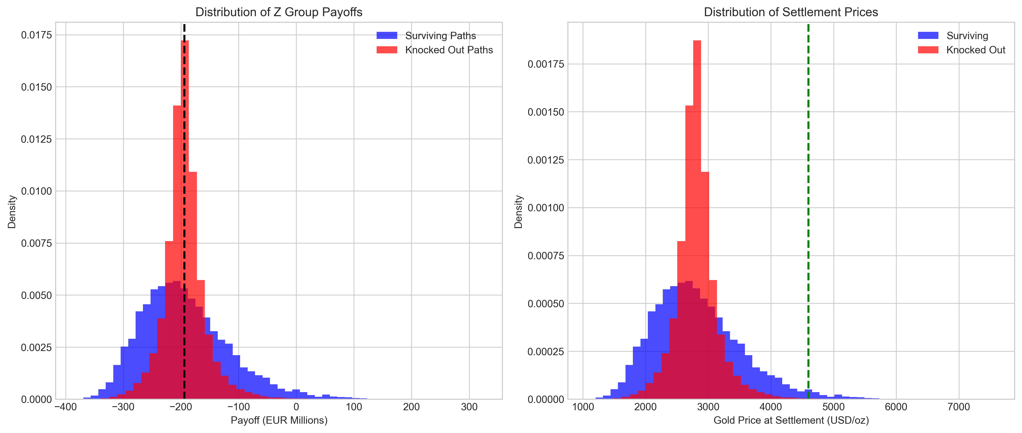

# 11. Conclusions and Recommendations

## 11.1 Summary of Findings

The proposed structure is technically sound and priceable using standard Monte Carlo techniques. However, two features merit discussion:

**1. Strike positioning:** The USD 4,600 strike creates a deeply out-of-the-money position for Z Group. Clarification of the commercial rationale is recommended.

**2. Barrier proximity:** The 93% knock-out probability results in an expected contract life of only 5 months—potentially misaligned with a 2-year hedging mandate.

## 11.2 Recommendations

We recommend proceeding to term sheet stage contingent upon:

1. 1. Confirmation from Relationship Management regarding Z Group's acceptance of the strike level and its implications
2. 2. Discussion of whether alternative barrier configurations (e.g., [1.00, 1.30]) would better serve the client's hedging objectives
3. 3. Documentation of appropriate risk disclosures regarding the high knock-out probability

## 11.3 Next Steps

Upon Committee approval, we will:

* Finalize term sheet documentation
* Establish hedging framework with Trading Desk
* Coordinate credit approval with Risk Management
* Schedule client presentation

**[END OF MEMORANDUM]**

# Appendix A: Nomenclature

|  |  |
| --- | --- |
| **Symbol** | **Description** |
| S_t | Gold spot price (USD/oz) at time t |
| X_t | EUR/USD exchange rate at time t |
| K | Strike price (USD 4,600/oz) |
| N | Notional principal (EUR 500M) |
| T | Maturity (2 years) |
| L, U | Lower (1.05) and upper (1.25) barriers |
| r_EUR, r_USD | Risk-free rates |
| σ_S, σ_X | Volatilities |
| ρ | Correlation coefficient |
| q | Gold convenience yield |
| τ | Settlement time |

# Appendix B: Figure Index

**Figure 1:** Monte Carlo Simulation Paths

**Figure 2:** Monte Carlo Convergence Analysis

**Figure 3:** Strike Price Sensitivity Analysis

**Figure 4:** Barrier Width Sensitivity Analysis

**Figure 5:** Risk Sensitivities Summary

**Figure 6:** Parameter Sensitivity Analysis

**Figure 7:** Cross-Model Validation

**Figure 8:** Payoff Diagram

**Figure 9:** Payoff Distribution